27.12: a) 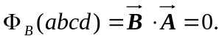
b) Wb.
c) Wb.
d) The net flux through the rest of the surfaces is zero since they are parallel to the x-axis so the total flux is the sum of all parts above, which is zero.

